StormVile Game Documentation

**PRGAP - Product Development Document**

*This documentation covers each phase from the requirements of the product through to the design and testing of the system.*

*Stormvile - 814853*

|  |  |  |
| --- | --- | --- |
| Version | Date | Comments |
| *1.0* | *04/02/2019* | *Requirements were defined for the project.* |

Contents

Features 7

Gameplay 7

1. Purpose 7

2. Scope 7

3. Definitions, acronyms and abbreviations 7

General Description 8

● Product perspective 8

i. Hardware 8

ii. Block Diagram 9

● Product Functions 9

● User Characteristics 9

● General Constraints 10

● Assumptions and dependencies 10

Specific Requirements 10

Textures Needed: 10

Models Needed 10

● Hardware Requirements 10

● Software Requirements 10

● Interface Requirements 11

a. U1 - Mouse (100 Mandatory) 11

b. U2 - Keyboard (100 Mandatory) 11

● Functional Requirements 11

a. F1 - Shooting (100 Mandatory) 11

b. F2 - Spawning Targets (100 mandatory) 11

c. F3 - Spawn Turrets (100 Mandatory) 11

d. F4 - Create Corridor (100 Mandatory) 11

e. F5 - Create Room (100 Mandatory) 12

f. F6 - UI (100 Mandatory) 12

g. F7 - Mesh Importer (100 Mandatory) 12

h. F8 - Texture Handler (100 Mandatory) 12

● Performance Requirements 13

a. P1 - The system will perform on average no less than 40 Frames per second 13

b. P2 - The system will have no sudden frame drops 13

c. P3 - The system will support the input of any keyboard and mouse 13

d. P4 - The system will initialise and run from hard-drive storage in under 10 seconds 13

e. P5 - The system will be able to run from removable storage formats given that the right DirectX version is installed. 13

f. P6 - The system will load levels in under 5 seconds. 13

g. P7 - The system will not close unless instructed to 13

● Reliability requirements 13

a. R1 - Mean time between failures will be 24 hours of game-play. 13

b. R2 - Failures can be caused by unknown player inputs/devices 13

c. R3 - The user will not be able to change controls these are hard coded in 13

● Design Constraints 13

Design Overview 14

○ Software Structure Chart 14

○ Screen Design 14

■ Main Menu 14

Game 15

Level Selector 15

○ Level Design 16

Detailed functionality description 17

● D1 - Texture Importer 17

○ Description: 17

○ Sub-Components: 17

○ Dependencies: 17

○ Used by: 17

● D2 - Model Importer 17

○ Description: 17

○ Sub-Components: 17

○ Dependencies: 17

○ Used by: 18

● D3 - Transformation 18

○ Description: 18

■ Sub-Components: 18

■ Dependencies: 18

■ Used by: 18

○ D4 - Collision Detection 18

■ Description: 18

■ Sub-Components: 19

■ Dependencies: 19

■ Used by: 19

● D5 - Targets 19

○ Description 19

○ Sub-Components: 19

○ Dependencies: 19

○ Used by: 19

● D6 - Shooting system 20

○ Description 20

○ Sub-Components: 20

○ Dependencies: 20

○ Used by: 20

○ D7 - Turret 20

■ Description 20

■ Sub-Components: 20

■ Dependencies: 21

■ Used by: 21

● D8 - Player Input 21

○ Description: 21

○ Sub-Components: 21

○ Dependencies: 21

○ Used by: 21

● D9 - Ship Flight 21

○ Description: 21

○ Sub-Components: 22

○ Dependencies: 22

○ Used by: 22

● D10 - Corridors and Rooms 22

○ Description 22

○ Sub-Components: 22

○ Dependencies: 22

○ Used by: 22

○ D11 - Text 23

■ Description: 23

■ Sub-Components: 23

■ Dependencies: 23

■ Used by: 23

Requirements Mapping 23

Maths 24

Text 24

Collision Detection 24

● Update 24

● Intersects 24

Transformation 24

■ Draw 24

Menu 25

■ Create Button 25

■ Update 25

Boundaries 25

■ Update 25

■ Spawn Target 25

■ Spawn Turret 25

Bullet 25

■ Update 25

Target 26

Player 26

Rooms 27

■ Setup 27

■ Update 27

Gun 27

Corridors 27

Main (Engine) 28

Project organisation 29

Life cycle model 29

Project organisational structure 31

Managerial process 31

Management objectives & priorities 31

Assumptions, dependencies & constraints 31

Risk management 31

Monitoring & controlling mechanisms 32

Staffing plan 32

Quality Planning 32

Source Control 32

File Name Scheme 32

Code Readability 33

Work packages, schedule & budget 33

Schedule 33

Budget 33

Project training plan 34

Test Plan and Results 34

Test Items 34

Test Report Results 34

Features not to be tested 35

Effective Project Procedures 36

Ineffective Project Procedures 36

Estimation Accuracy 37

Recommendations 37

Personal Reflection 38

Appendix 41

References 42

# 

Introduction

## Features

* Model Importer
* Random Targets (Health can be different)
* FPS
* Laser Bullets
* Flashlight
* Text

## Gameplay

Fly around in tight corridors

Shoot random targets or turrets

Go as quickly as possible

Do not waste bullets

## Purpose

* 1. This document details the design of an interactive 3-Dimensional product for submission along with the implemented product at the end of the DIRXENG course.

## Scope

* 1. The development will be of a product that allows a user to interact and do the following:
     1. Go through 5 pre-made levels
     2. Shoot at targets
     3. Timed on how quickly they go
     4. Counts the number of shots fired
     5. The object is to clear the trench and not waste shots

## Definitions, acronyms and abbreviations

* 1. *O-O – Object Oriented.*
  2. *DirectX – A Game SDK used to handle the input and output aspects of game play.*
  3. *Procedural - Generation of a level/assets using random elements*
  4. *Assets - Game objects/models e.g. Tree/book*
  5. *Level - Premade/user made layout of objects place in a position to create a world*

System Requirements Specification

# General Description

This Section describes the general factors that make the product and what requirements they have. IT does not state specific requirements, it just makes those requirements easier to understand

## Product perspective

* 1. *The product will be developed to run on Windows computers capable of effectively running DirectX 11.0 or greater.*

### Hardware

* + - 1. PC Keyboard and Mouse. No controllers, joysticks
      2. Medium End Gaming PC
      3. 1920 *1080 monitor
      4. Static Window resolution

### Block Diagram

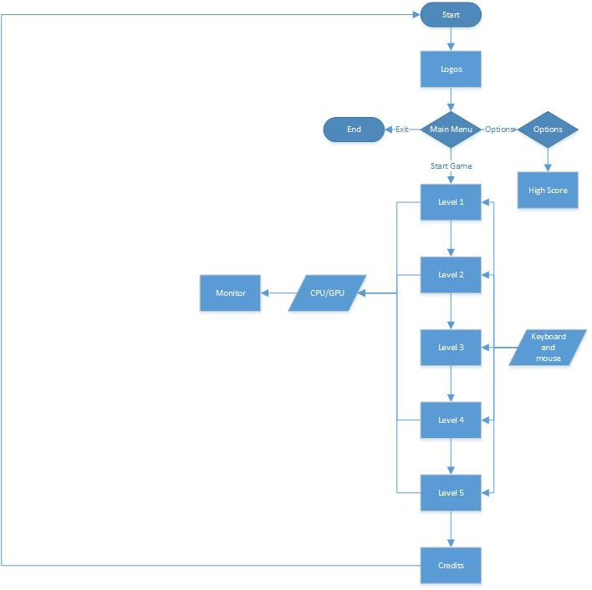

Figure 1 - Block Diagram

## Product Functions

* 1. The game will allows the user to take control of a star-ship going through tight and narrow corridors. The game will allow the user to move this ship in a 360 degrees with a 3RD person camera locked to the ship. The game will also allow the player to change this camera to be first person. There is possibilities for the game to have UI elements like crosshairs and additional information. When the user interacts with the ship they can accelerate it in the direction it is facing. The ship will be speed clamped to slow down. When the user hits a wall they take damage represented by the ships colour.

## User Characteristics

* 1. *The user will be academics and students within the University of Portsmouth that are familiar with the use of computers and 3D graphical applications.*

## General Constraints

* 1. *The development of the product will be designed and implemented for the lab environments within the University of Portsmouth.*
  2. *The game requires a 1920 * 1080 resolution so the gameplay experience is more uniform.*

## Assumptions and dependencies

* 1. The developers assume people playing this game have a “gaming” PC capable of handling basic gameplay, the game has multiple objects with differing textures and basic lighting, this can cause lag on older PCs
  2. I assume the user has Windows 10.

# Specific Requirements

*This section provides comprehensive detail on all requirements. It should include all of the detail, which the designer will need to create the design*

## Textures Needed:

Text

Modern Brick

Ancient Marble

Futuristic Carbon Wall

LED Wall

1 Ship texture

## Models Needed

Ship

Gun

Bullet

Turret

Wall

## Hardware Requirements

* 1. *Computer:*
  2. *i5*
  3. *Hard Drive 4GB space*
  4. *GTX 970*
  5. *8GB Ram*
  6. *Monitor:*
  7. *Any 1920*1080 monitor*

## Software Requirements

* 1. *DX11 Installed on PC*
  2. *Windows 10*

## Interface Requirements

### U1 - Mouse (100 Mandatory)

* + 1. Left Click: Fire Weapon
    2. Moue: Aims Gun Gimbals

### U2 - Keyboard (100 Mandatory)

* + 1. W: Rotate Down
    2. S: Rotate Up
    3. A: Strafe Left
    4. D: Strafe Right
    5. E: Rotate Ship Right
    6. Q: Rotate Ship Left
    7. lShift: Thruster Increase
    8. Control: Thruster Decrease
    9. R: Centre Guns
    10. X: Breaks
    11. Space: Fire Weapons
    12. Left: Rotate Camera Left Around Player
    13. Right: Rotate Camera Right Around Player
    14. Up: Rotate Camera Up Around Player
    15. Down: Rotate Camera Down around player

## Functional Requirements

### F1 - Shooting (100 Mandatory)

* + 1. The program will shoot bullets from a gun placed on the player ship

### F2 - Spawning Targets (100 mandatory)

* + 1. The program will spawn targets on walls or floors at random intervals and amounts
    2. Game logic should keep track of number of targets

### F3 - Spawn Turrets (100 Mandatory)

* + 1. The program will spawn turrets on walls or floors at random intervals and amounts
    2. Game logic should keep track of number of turrets

### F4 - Create Corridor (100 Mandatory)

* + 1. The program can create corridors at a set length ( max 50)
    2. The floors will be separate so you can handle textures and lighting better

### F5 - Create Room (100 Mandatory)

* + 1. The program can create 4 rooms
       1. 2 x 2
       2. 3 x 3
       3. 4 x 4
       4. 5 x 5

### F6 - UI (100 Mandatory)

* + 1. The program displays stats like health and ammo used and time

### F7 - Mesh Importer (100 Mandatory)

* + 1. The program imports meshes from OBJ files

### F8 - Texture Handler (100 Mandatory)

* + 1. The program imports textures from DDS

## Performance Requirements

### P1 - The system will perform on average no less than 40 Frames per second

### P2 - The system will have no sudden frame drops

### P3 - The system will support the input of any keyboard and mouse

### P4 - The system will initialise and run from hard-drive storage in under 10 seconds

### P5 - The system will be able to run from removable storage formats given that the right DirectX version is installed.

### P6 - The system will load levels in under 5 seconds.

### P7 - The system will not close unless instructed to

## Reliability requirements

### R1 - Mean time between failures will be 24 hours of game-play.

### R2 - Failures can be caused by unknown player inputs/devices

### R3 - The user will not be able to change controls these are hard coded in

## Design Constraints

* 1. *The target hardware system will be a I7*
  2. *The memory available will be 4GB of main memory.*
  3. *The size of the final product is restricted to the size of the CD-ROM format (under 700Mb).*
  4. *The graphics hardware required will be an NVidia GeForce 4.*
  5. *The computer system will have the DirectX 11 runtime installed.*
  6. *The user will not be able to use a controller or joystick*
  7. *Textures and models are basic to save performance.*

Software Design Description

# Design Overview

This section details the high-level look at the program and is used as a road-map to further define the component detail in the following sections.

## Software Structure Chart

* + - (In Project File Go to: Stormvile\Stormvile\Design)
    - Appendix 1: Software Structure Chart

## Screen Design

### Main Menu

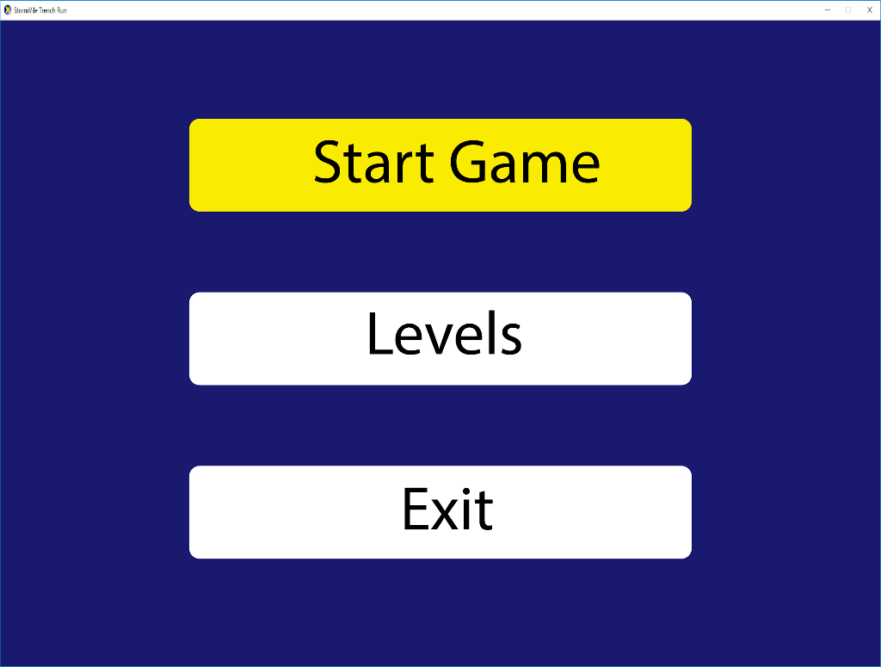

Figure 2 Main Menu Screen design

### Game

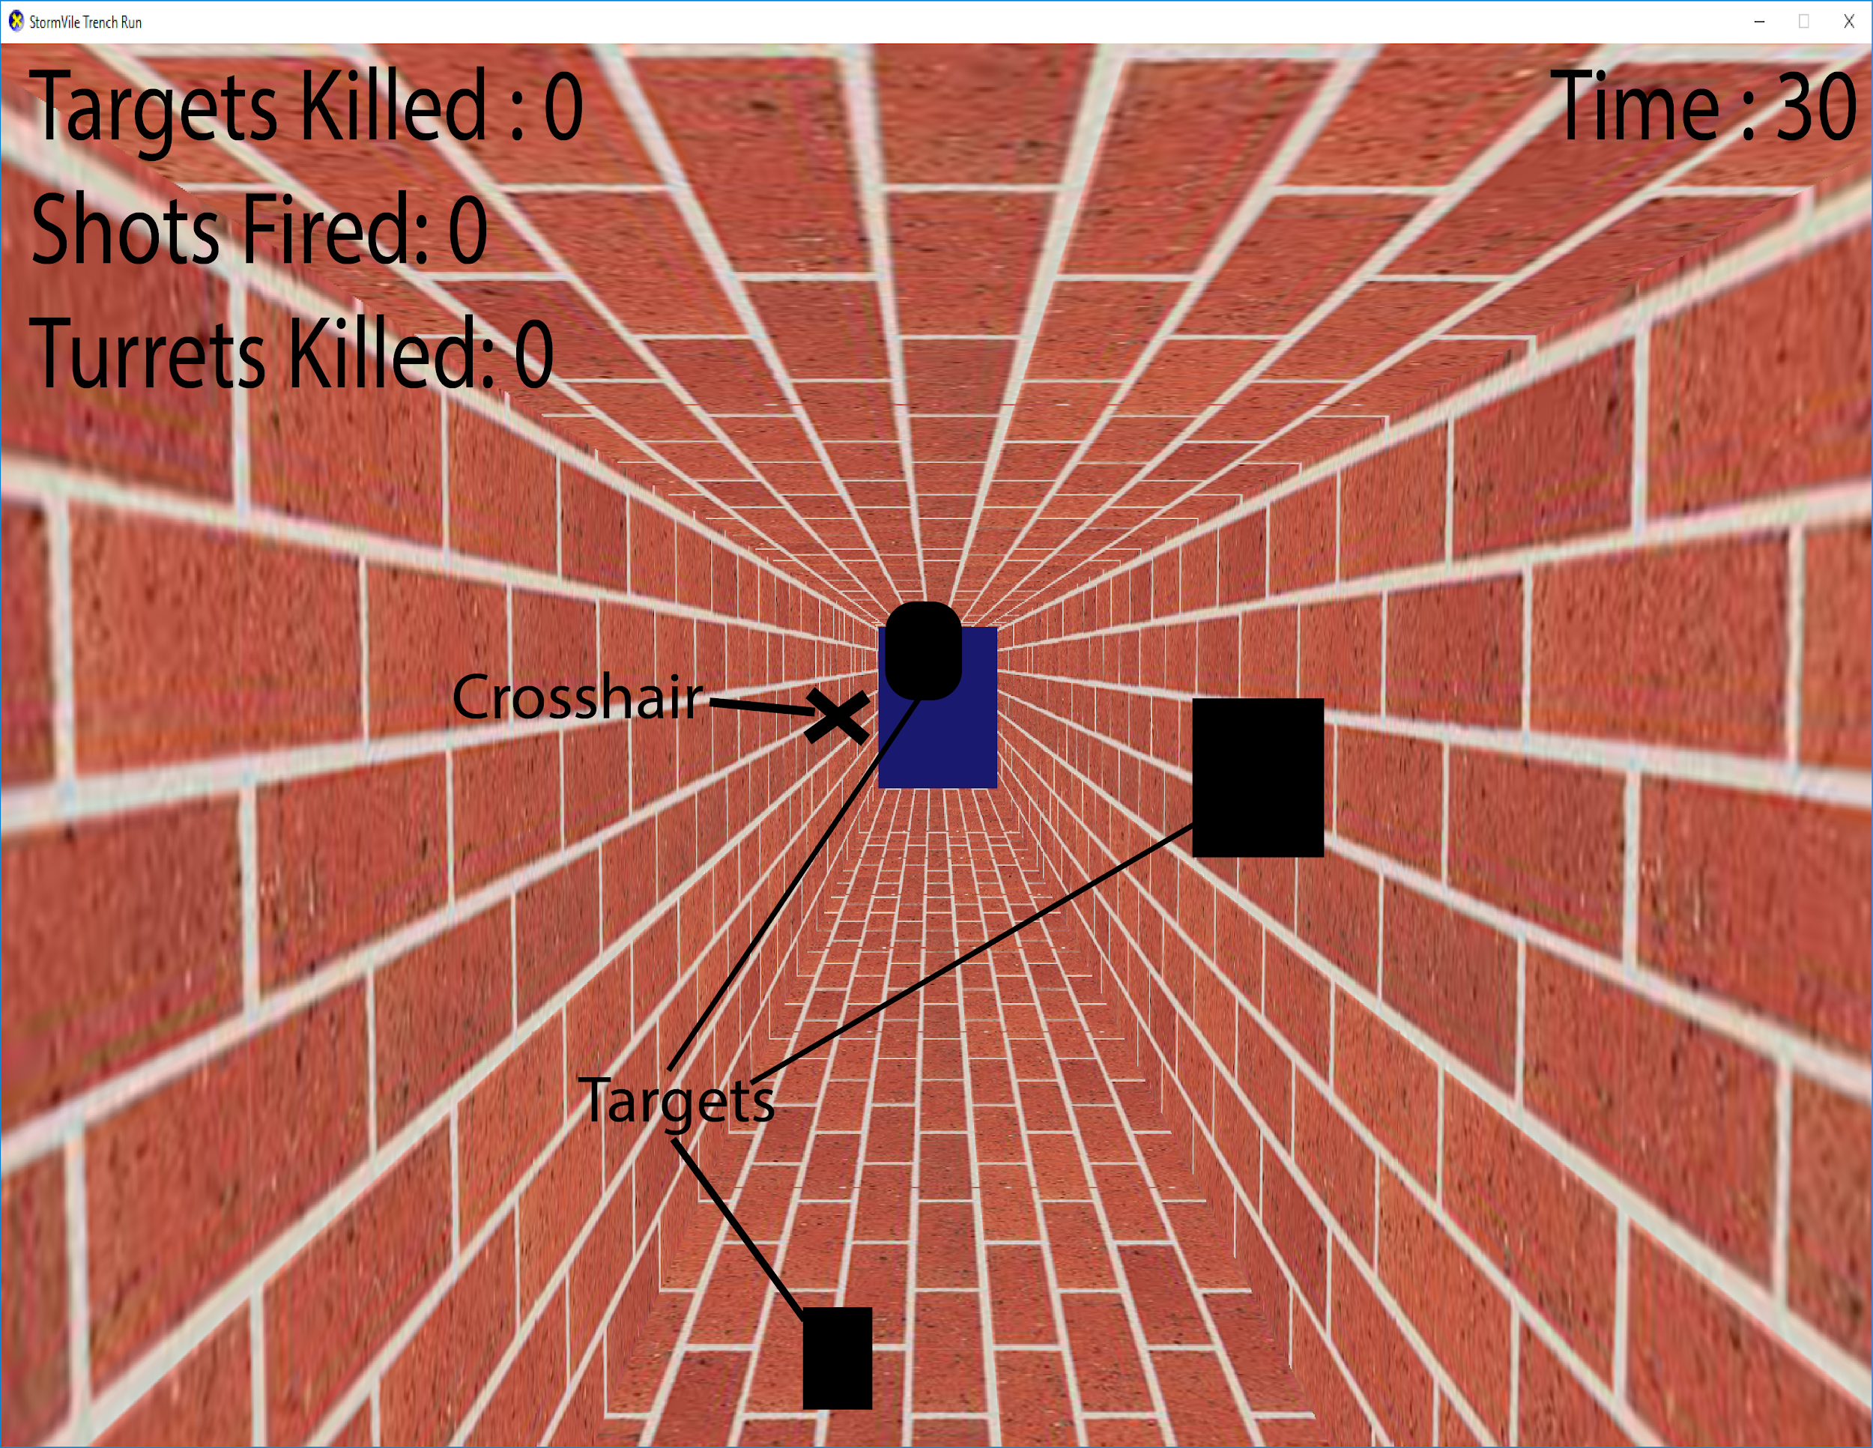

Figure 3 Game Screen Design

### Level Selector

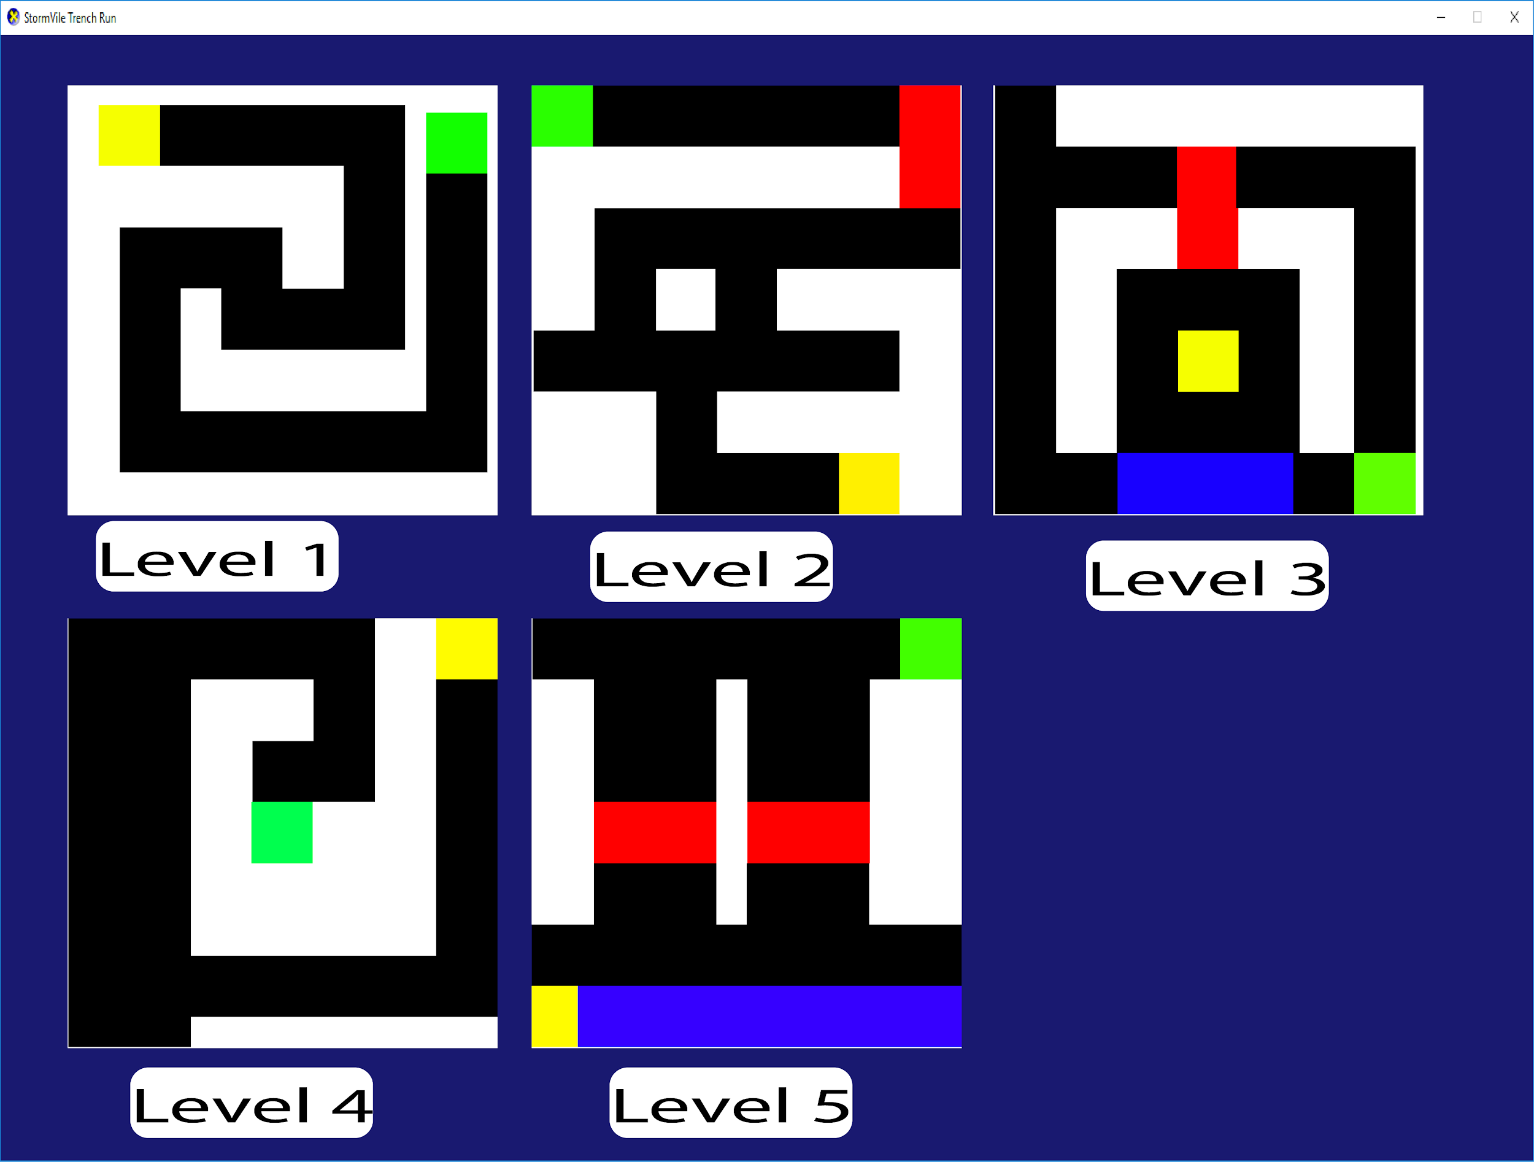

Figure 4 Level Selector Screen Design

## Level Design

Level 1 Level 2 Level 3



Figure 5 Level 1 Design Figure 6 Level 2 Design Figure 7 Level 3 Design

Level 4 Level 5



Figure 8 Level 4 Design Figure 9 Level 5 Design

Level 1 is a simple snake like level, black represents the corridors positions, Yellow is where the player starts and green is the finish. The level designs are not what the final level will look like but more of an idea of how to layout the level for the player and a general structure needed.

Level 2 brings in the concept of multiple pathways and shorter corridors, it also adds a new colour red, red is a vertical shaft up or down for the player to fly in. The player must again reach the green cube to go to the next level. Turrets and targets can spawn on either end of the connecting corridors and this can add challenge to the player

Level 3 starts in a room, the room size will be determined in the programming phase, to get out of the room the player must fly up/down the shaft to enter a corridor, this corridor will go around in a circle, with a dead end, and the dead end is guaranteed to have a turret. The blue colour is used to represent that it is on a different level to the black room the Green cube is on a corner

Level 4 goes back to a more basic concept but with a wider corridor/ room this will give the players more space to shoot and fly around in and the level is more build for fast speeds. The Corridors go tight quickly giving the player a chance to crash and die

Level 5 the most complex level to create in game this level will require a lot of manual setups with the prefabs. The player starts in the bottom left, the blue corridor is separate to the black corridor with an entrance at the end. The player then has a choice of two wide corridors, both of these corridors have a shaft going up to the next level the player can then make their way to the green end.

# Detailed functionality description

This section Details the functionality of classes, their purpose, pseudo code of what they do and any dependencies of sub components

## D1 - Texture Importer

### Description:

* + - The Texture importer, imports textures from DDS files, the purpose of this is to have external textures such as bricks. DDS files can be read from file and applied in main

### Sub-Components:

* + - DX11

### Dependencies:

* + - DX11
    - DDS

### Used by:

* + - Main/Transformation
    - Objects and Meshes

## D2 - Model Importer

### Description:

* + - The model importer reads obj from file and applies their model data to the mesh structure used by DX11, this can include UVS to apply textures. This is optional
      * Read file from directory
      * Vertex Buffer = Obj Model Vertices by reading the file line by line and getting the vertex point
      * UV = Obj Model UV
      * Store In memory

### Sub-Components:

* + - * DX11

### Dependencies:

* + - * DX11

### Used by:

* + - * Transformation
      * Main

## D3 - Transformation

### Description:

* + - Main Transformation component which is used by all objects to define where they are in the world, how big they are, their rotation and their colour
      * Update Transformation:
      * Position = new Position (XMFLOAT3 (0, 0, 0));
      * Scale= new Scale (XMFLOAT3 (0, 0, 0));
      * Rotation= new Rotation (XMFLOAT3 (0, 0, 0));
      * Red = 50
      * Blue = 10
      * Green = 1

### Sub-Components:

* + - * DX11
      * Mathf
      * Vector Maths
      * Collision Detection

### Dependencies:

* + - * DX11

### Used by:

* + - * All Game Objects
      * Collision Detection

## D4 - Collision Detection

### Description:

* + - * AABB Based Collision detection using basic collision checks to increase performance all objects have a AABB box that automatically updates every frame
      * Intersect tests are done in main but the functionality is in collision detection
* Update
* AABB MIN = Transformation - Scale
* AABB Max = Transformation + scale
* Intersects (AABB BOX1, AABB BOX2)
* Check if Min is more than max is so swap them
* If (BOX1 is in BOX2)
* Return true
* Else
* Return false

### Sub-Components:

* + - * Transformation

### Dependencies:

* + - * Transformation

### Used by:

* + - * All Game Objects

## D5 - Targets

### Description

* + - Class that handles and spawns targets in for the player to shoot, these targets are static but still need to check for collision detection
      * Update
      * Get Bullet list from player’s gun
      * Check bullet I box against target box
      * If collision is true
      * Set game logic score to +1
      * Set Shots fired to +1
      * Destroy target

### Sub-Components:

* + - Transformation
    - Collision Detection

### Dependencies:

* + - Collision Detection
    - Transformation

### Used by:

* + - Level Creation

## D6 - Shooting system

### Description

* + - Handles the shooting of bullets from guns, handles any physics involved and the timeout destructor
      * Fire
      * Get Gun Position
      * Get Gun Rotation
      * Shoot Bullet Direction from gun rotation
      * Apply Speed
      * Update for 10 seconds
      * Destroy
      * Update Bullet direction + speed

### Sub-Components:

* + - Transformation

### Dependencies:

* + - Transformation

### Used by:

* + - Gun

## D7 - Turret

### Description

* + - * The turret module handles and creates the turret, it gets the player position and see if they are in distance to start shooting, and it then shoots at the current player position at a set speed.
        + Update
        + Get players location
        + If Distance is less than 50
        + Shoot at player
        + Get players bounding box
        + Check Turrets Bullet list against player’s collision
        + If collision is true reduce health

### Sub-Components:

* + - * Transformation
      * Shooting system

### Dependencies:

* + - * Shooting system
      * Transformation

### Used by:

* + - * Level Creation

## D8 - Player Input

### Description:

* + - Get keyboard and mouse input from windows and complete actions based on player input
      * Switch (Keyboard)
      * Case A
      * Strafe Left
      * Case D
      * Strafe Right
      * Case W
      * Pitch Down
      * Case S
      * Pitch Up
      * Space
      * Shoot

### Sub-Components:

* + - Windows SDK

### Dependencies:

* + - Windows SDK

### Used by:

* + - Player Input

## D9 - Ship Flight

### Description:

* + - Part of the player functionality accurately flies and moves the ship depending on player input
      * If Acceleration = true
      * Speed = 5;
      * Direction += speed

### Sub-Components:

* + - Transformation
    - Player Input

### Dependencies:

* + - Transformation
    - Player Input

### Used by:

* + - Player

## D10 - Corridors and Rooms

### Description

* + - Creates Corridors And rooms
      * Create a floor with a scale of 5
      * Creates walls with the same size and offset
      * Get Corridor Size
      * Create floors for how long the corridor is
      * Put the corridors in the direction intended
      * Make sure corridor collision detection is updated
      * Per floor randomise if it gets a turret / target
      * Choose a turret / target
      * Randomise wall/floor/roof

### Sub-Components:

* + - Transformation
    - Turrets
    - Targets

### Dependencies:

* + - Transformation
    - Turrets
    - Targets

### Used by:

* + - Player

## D11 - Text

### Description:

* + - * Converts String to Displayable text
        + Get Number
        + Get Text to display before number
        + Combine the two
        + Convert it to wchar
        + Display wchar using sprite batch

### Sub-Components:

* + - * DXUT
        + Sprite Batch

### Dependencies:

* + - * DXUT
        + Sprite Batch

### Used by:

* + - * Game logic

# Requirements Mapping

This section details a trace-ability matrix to map the requirements to the design functionality.

Requirement

|  |  |  |  |
| --- | --- | --- | --- |
| Requirement | Design | Mandatory | Importance (0-100) |
| *F1* | *D6* | *Y* | *100* |
| F2 | D7 | Y | 100 |
| F3 | D5 | Y | 100 |
| F4 | D10 | Y | 100 |
| F5 | D10 | Y | 100 |
| F6 | D11 | Y | 100 |
| F7 | D2 | N | 70 |
| F8 | D1 | Y | 100 |

Full function Plan

This sections details all the functions needed per class, data types will be determined when the function is created. The plan does not include data types of structures as these can be changed function by function, it does not include optional

# Maths

* + - The maths class is a more generalised lengthy class of functions to handle vector maths related to the game mechanics and objects. This is from simple operations like addition and subtraction to more complicated functions like vector lerp and forward direction function used for ship movement

# Text

* + - DXUT function that handles the text display in game

# Collision Detection

## Update

* + - * + Get position
        + Get Scale
        + Min = Position - Scale
        + Max = Position + Scale

## Intersects

* + - * + Get Box1
        + Get Box2
        + Intersect test for two box
        + If intersecting return true

# Transformation

## Draw

* + - * Get Position, Rotation, Scale, Colour Red, Green blue
      * Transform Rotate Then Scale
      * Apply Colours

# Menu

## Create Button

* + - * Location
      * Colour
      * Text
      * Button Action

## Update

* + - * If mouse is on button highlight = true
      * If highlight is on button highlight = true
      * Highlight = keyboard input W up D down

# Boundaries

## Update

* + - * Check grid.
      * Check if player is in grid
      * If player is in grid check collision detection

## Spawn Target

* + - * If number is in the percentage chance of a target being spawned target = true
      * Randomise wall
      * Offset according to wall
      * Store In memory

## Spawn Turret

* + - * If number is in the percentage chance of a turret being spawned turret = true
      * Randomise wall
      * Offset according to wall
      * Store In memory

# Bullet

## Update

* + - * Get velocity
      * Timeout Destructor
      * Transformation + Velocity
      * Check Bullet Collision
      * Set Transformation

# Target

* + - Update

If Bullet is in Grid 10

If Target Is in Grid 10

Perform Collision Detection Test

If Colliding Destroy Target

Add one to target score

# Player

* + - Update

Forward Direction = Rotation

Right Direction = Cross Product of Forward Direction

If Q == true

Rotation.y -= 0.05;

If e == true

Rotation.y +=0.05

IF w == true

Rotation.x -= 0.05

If s == true

Rotation.x +=0.05

If A== True

Velocity.X -= Right Direction;

If D == true

Velocity.X +=Right Direction

If Space == true

Player Gun.Fire

If (Shift == true)

Velocity += Forward Direction

If (LControl == true)

Velocity -=Forward Direction

Check against Boundaries in Grid

If Colliding Player dead == true

If Colliding in Finish Grid stop time

Next level

# Rooms

## Setup

* + - * Get Room Size
      * If 2 BY 2
      * Create 4 Floors
      * Have Walls Open
      * Close Outside Walls
      * Create Percentage Chance Of Turrets and targets
      * Setup Collision

## Update

* + - * Check Room Grid Against Players and Bullets
      * If Collided Kill Player

# Gun

* + - Setup
      * Set Gun Position
      * Set Bullet Pool Size
      * Set Gun Rotation
    - Update
      * Update Bullet Array
      * Update Position and Rotation
    - Fire
      * If bullet fired = false then
      * Get Gun Position and Rotation
      * Velocity = 10
      * Bullet fired = true

# Corridors

* + - Setup
      * Get Corridor Length
      * Get Corridor Direction
      * If Corridor Direction = left
      * Create Floor Prefabs going to left direction
      * Length = floors used
      * Max is 50
      * Have Walls Open
      * Close Outside Walls
      * Create Percentage Chance Of Turrets and targets
      * Setup Collision
    - Update
      * Check Collision Against Player

# Main (Engine)

* + - Main/Render
      * This functions handles most of the DX11 functionality, in broad terms it reads a texture from a file and stores it, the device context is set and updated in the render code where the draw functions are called.
      * DX11 handles most of the graphics API however I still need to set the device context, P3D devices and the context buffer to get the drawing working. I also need to make sure each object has a position and colour in world space otherwise the vertex buffer will not draw.

Project Plan

# Project organisation

### Life cycle model

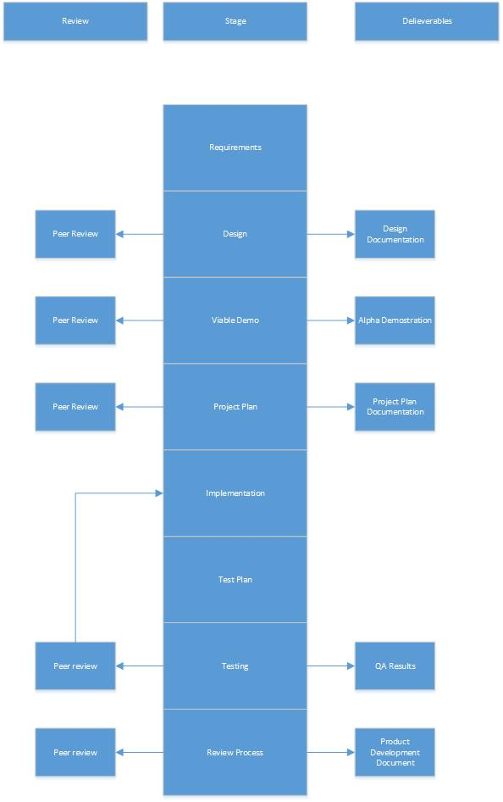

Figure 10 - - Project Life cycle model.

### Project organisational structure



Figure 4.1.2.1 – Organisational structure chart.

# Managerial process

### Management objectives & priorities

The progress of the project will be discussed informally in the workshop session for the course each week.

The aim is to create a product that meets the requirements and design and is delivered on time to a high-level of quality.

Peer reviews will be performed within the workshop environment to help review the progress of the project and reassess the projects risks

Peer reviews will be informal discussions and feedback on the current version of the product.

### Assumptions, dependencies & constraints

The project will be completed by the due date of the final submission, which is the date of April of the 5th.

The hours allocated to implement the project is 8 hours per week totalling 176 hours for the project.

The Project will be constrained in development time by other projects including Unity and PS4 Projects.

### Risk management

The results of the latest risk management performed is detailed in the following table:

|  |  |  |  |  |
| --- | --- | --- | --- | --- |
| Event or Risk | Probability | Severity | Preventative steps | Contingency |
| *Corruption of work* | *Low* | *High* | *None* | 1. *Internet backups* 2. *Zip backups* |
| Death | Medium | End of project | Good exercise and food | Posthumous |
| Loss of work | Low | High | Backup Work  Source Control | Revert to latest source |
| Fire | Medium | Low | Fire-extinguishers | Move to library |
| Flooding | Low | Medium | None | Move to library |
| Internet Down | Medium | High | Internet Maintained | Memory Stick Backups |
| GitHub Shutdown | Low | Medium | None | Move to new source control |
| Building Closed | Medium | High | Extend Open hours | Work at home |
| Computer Failure | High | High | Computer maintained | Use latest backup  Work at new PC |
| Virus | Medium | High | Anti-virus software | Revert to source |
| Microsoft shutdown windows | Low | End Of Project | None | Rebase project on new operating system |
| Personnel Injury | Low | Medium | Be careful | Work at home |

### Monitoring & controlling mechanisms

This is an individual project with the use of peer review techniques with fellow students as well as staff during workshop times to review project progress according to the timeline detailed in the document.

### Staffing plan

The project is an Individual approach with peer reviews performed by one other student and one other staff member.

# Quality Planning

This section determines procedures and details for how quality will be maintained on the product. Detail source code commenting standards, file naming scheme, and methods used for version control of both source-code and art assets.

### Source Control

Source control will be performed on GitHub, using the desktop application git kraken. To ensure the code is backed up and to revert any major changes that brake the game. The source will be updated after an implementation of a function of feature of the game. The version control has multiple branches depending on what is being developed.

### File Name Scheme

Files will be named in plain English with no syntaxes or code so anyone can read the file name. Folders will be named for what they contain E.g. Design contains the images and files that were created for this documentation.

### Code Readability

To ensure code readability I have used my own naming convention in which I stray away from using PP1 instead having Player.Position which gives whoever is reading the code a higher chance of understanding it. There are also comments on the blocks of code which gives users even more indication of what a section is doing.

# Work packages, schedule & budget

This section defines the schedule of work. In a team environment you would also include a work break down structure to allocate work across a team.

### Schedule

Difficulty:

Low: 1 Hour implementation

Medium: 3 Hour implementation and test

High: 1 day implementation and tests

Risk –

Low: No risk to project

Medium: Can cause computability issues or minor errors

High: Can break the project leading to crashes and major errors

|  |  |  |  |
| --- | --- | --- | --- |
| Function | Difficulty | Risk | Time |
| *F1* | Medium | Low | 1 Day |
| F2 | Low | Low | 1 hour |
| F3 | Low | Low | 1 hour |
| F4 | Low | Low | 2 hours |
| F5 | High | Medium | 4 hours |
| F6 | Low | High | 3 days |
| F7 | High | High | 4 days |
| F8 | High | High | 2 days |

### Budget

|  |  |
| --- | --- |
| Function | Cost |
| *F1* | £100 |
| F2 | £10 |
| F3 | £10 |
| F4 | £20 |
| F5 | £50 |
| F6 | £00 |
| F7 | £400 |
| F8 | £200 |

# Project training plan

No training will be required for the users of this product.

# Test Plan and Results

## Test Items

This section details the test cases for the product along with the test result. This document will be revised in version for each time the set of test cases is carried out.

|  |  |  |  |
| --- | --- | --- | --- |
| Requirement | Test | Test Case | Status |
| *F1* | *T1* | *User Can shoot* | *Passed*  *2/04/19* |
| *F2* | *T2* | *Level Spawns in Targets* | *Passed*  *2/04/19* |
| *F4* | *T3* | *Level Spawns in Corridors* | *Passed*  *2/04/19* |
| *F5* | *T4* | *UI updates and creates* | *Passed*  *2/04/19* |
| *F6* | *T5* | *Meshes Are Imported correctly* | *Passed*  *2/04/19* |
| *F7* | *T6* | *Textures Are imported correctly* | *Passed*  *2/04/19* |
| *F8* | *T7* | *Import a second model* | *Failed 2/04/19* |

Table 5.1.1 – Trace-ability matrix from section 3.3 with test cases and test result information.

## Test Report Results

**Date:** 2/4/19

Tested: T1:T6

**Issues Encountered:** With this test I went through all the functions to ensure they were working. When I tested this I found little to not issues. The only issue I found was when the player pointed up the camera would gimble lock causing you to look at the ships backside and not be able to see where you are going.

**Date:** 2/4/19

Tested: T7

**Issues Encountered:**

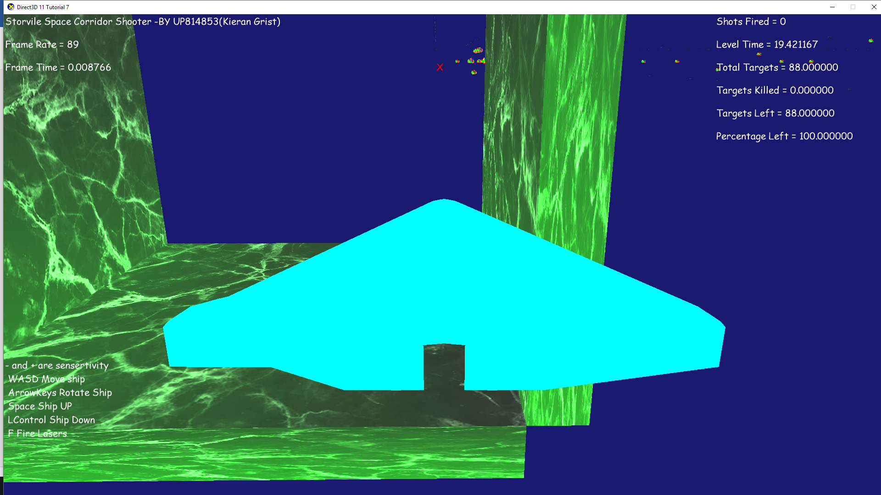

## Features not to be tested

Identify functions that are not to be tested and specify reasons.

|  |  |
| --- | --- |
| Function | Reason |
| User Input | No reason to test if it works as the input is hard coded |
| End Screen | The end screen is dependent on collision detection, we would just end up testing collision detection again |
| Room | Failure to implement feature |
| Turret Creation | Failure to implement feature |

Post Project Review

The post-project review is an information gathering and evaluation exercise to determine what worked well and what did not during the personal project. From this recommendations are drawn about how projects can be run more effectively in the future.

# Effective Project Procedures

I have encapsulated the code so that someone can spawn in a boundary with a structure and all they have to do is call update and the update function handles the rest. This was done with all classes and uses basic polymorphism techniques to insure inheritance is done correctly.

The Boundaries class went well when creating it and using it, I came up with a method to generate a closed block around a point, each side of the block. My original project plan would be ineffective and unfit for purpose, I had planned to check if the player was in the grid which would cause framerate issues and possibly lag the game till it is unplayable. I kept the idea and implementation of the Spawn target feature.

The Collision Detection class is very effective at its job, being attached to the game object class, any object can collide with another object and use the collision detection functionality. Comparing my implementation to the project plan I have kept to the plan and not differed from it. For this functionality I kept it simple and low on the processor with it only being called when collision detection is needed within the game. I do this in the collision detection loop inside level update, the game checks if bullet 1 is alive, it then checks if the target is alive, if both are true it checks a collision between the both.

This saves power with bullet 50 being dead it will not check against any objects. I have also implemented this with the walls with the collision detection loop going through the walls and saying, if left wall is true check for Collison against player. If this was false it would allow the player to fly through the invisible wall.

# Ineffective Project Procedures

For the Room class a lot of techniques and methods went wrong at the same time, the room class was created to create and update a 10 by 10 room made out of the boundaries. However as soon as there was any collision detection the program took a heavy performance dive. My implementation of this was very much like the project plan indicating that the method I chose to implement the rooms was incorrect and not fit for purpose. The next procedure would be to try and import a mesh of a room as this will be less intensive then 600 game objects.

For Bullets I used a pooling technique to go through 50 bullets which are already in memory, however this is ineffective and there are better techniques to create and update the bullets including vectors and dynamic arrays. Comparing to the project documentation I have kept to the plan with the classes’ functionality, the only feature that needs to be changed is the pooling technique.

For Game object I should have used more advanced polymorphism techniques so that I can pass any object that has a game object and process it all under-one function. This function can call update versions on any game object and it will run the code. Instead I have a basic game object class which has transformation and collision detection, and can contain a texture for it to be drawn with. Specific techniques

# Estimation Accuracy

|  |  |  |
| --- | --- | --- |
| Function | Estimated Time | Actual Time |
| *F1* | 1 Day | 3 Days |
| F2 | 1 hour | 4 Hours |
| F3 | 1 hour | * Not Implemented |
| F4 | 2 hours | 10 Hours |
| F5 | 4 hours | 8 hours |
| F6 | 3 days | 4 Days |
| F7 | 4 days | 1 day |
| F8 | 2 days | 1 day |

My estimations were incorrect for the project, the implementation of functionality in most cased took longer than expected, in one case with the room the class was not implemented at all due to a lack of time and experience. Having estimated times in my project did not help as they were layaways inaccurate as I would often run into bugs and graphical issues with the project when I added in a new class.

# Recommendations

On reflection there is a number of ways, methods and techniques that I could of used to my advantage to make this a better game and a more viable product. The software as is, can spawn in corridors of a various length and update the contents inside and keeps all of this code away from the user so all they have to do is call setup and the function does all the heavy work for them. However there was techniques I could have used to make the product better.

The first method is to use programming techniques such as polymorphism in my code to make the code more usable and more efficient. Under this I would also use pointers and object types more writing a system that allows me to handle a class at once instead of one object. This system would work using the As Technique, this lets me say, If Object 1 is a Bullet Call Bullet Collision System, allowing me to dynamically check object types. I can also use this technique to create a bullet from a game object, Simply going Create Bullet = Game Object As Bullet, with a constructor function dealing with that behind the scenes and having a bullet fire from the game objects position.

The second method is a more robust graphics pipeline that allows me to load more than one object. When I was creating the mesh loader I had a massive issue for when I imported a teapot and the space ship model where the cubes went invisible with other graphical issues as well.



Using ENUMS and other methods to handle the keyboard inputs and also implement file readers so users can change and save their key bindings to how they want. This integration would also include joysticks and controllers which was one of my far of stretch goals to allow the user more fine input. The file readers would also allow the user to have high scores, however the random element of the game makes it harder to have a fair compotation.

# Personal Reflection

For this project. I modified Tutorial 7 to make a 3D game and with a 3D camera system that follows the player and has a physic and collision system. However at the start I struggled with how the systems of DirectX worked my primary struggle was understanding how they draw their objects and how their co-ordinate system worked. After 6 weeks of creating prototypes I had a moderate understanding of direct x, this was until I done a small game jam held by our lecture. I found this game jam super useful as it put me under time pressure to create a game in direct x, within this week I created a game where you could place objects on a ship and got collision detection working.

After I had a “Game” Working I moved onto thinking about this project, the project started out as a first person shooter, where you would go into a kill-house and shoot targets and have a score at the end. This changed in the middle of me debugging the corridor generation I found it fun to fly through the corridor so I changed the game to be a space corridor shooter.

I decided to implement one class at a time, instead of all at once which could cause a cluster of issues and computability errors and make debugging the game harder to do. With this I focused on target generation and collision detection, as the corridor generation was working from an early stage creating a game from what I already had was a high priority.

I struggled to get the bullets to draw on screen, they were updating in the code but they were not showing on the screen, to fix this issue I simply made sure that the bullets were not destroying their force after it had been applied. While this does cause a constant force to be applied in one direction it fixed the bullets not drawing. After I had the bullets colliding and the player colliding it was then moving onto the level generation.

The level generation took me 3 hours to get fully set up, this was as the code to set up a corridor was tedious as I would often lose reference of where I was in the 3D world and the level generated with trial and error methods.

On reflection with this project the collision detection should have been done with some form of special partition system so bullets and the player would only check for collisions with objects that are around them, this would improve framerate and allow for the room to be implemented. Also instead of finding out why the bullets were not drawing I opted for an easy and lazy fix which did not fix the original code instead created a work around.

I could have made the setup more efficient by not including unneeded initialise values that were not being needed such as rotation and scale for most initialisers were being overridden, an example of this is the boundaries class which takes in a scale value but does nothing with it.

There is no simple way for me to create a corridor and then set it up latter or dynamically change it and move it around, I have to do it using the setup functionality otherwise it will not work. This is one disadvantage for abstracting my code and using structures as I should have had smaller functions that would allow me to more dynamically create a corridor.

At the start of the project I was head strong on creating a game and ignored the documentation. This was not the wisest approach to this project as it would leave me often guessing what I need to do and have no plan to follow. After I got ahead of the workshops I got hubristic leaving the documentation and working on game and this left me needing to do the documentation before I could carry on working on the game. When I finally did the game documentation I had more of a plan and idea of what I was doing and what was needed to be created, I quickly learnt the systems of DirectX and how to create a video game from this. I personally feel like I done very well with the game made and the time I created it in. Within 4 months I created a game that can load in one model and shoot lasers in a corridor.

However I struggled at certain points often hitting roadblocks which seemed impossible to overtake and errors in code that would leave me wanting to reset the whole project. The mental strength to carry on the project and the lessons I learnt have made me a better programmer towards industry learning how to handle the pressure of a big assignment and still complete the tasks that I set out.

I missed out some sections of the plan and did not have a schedule writing down ahead of time, this was a personal flaw as it left me needing to do a schedule after I created the code and I lost track of when I done items and how much time it took. I had a rough schedule in mind thinking how long a certain function would take but did not realise I needed the dates.

If I was to do this project again I would not do the first 3 sections instead I would get up to the testing plan and make sure before I even make a game I had a full plan of how I want to make it and what I want to do with it.

I learnt how to handle a project on my own from this, I also learnt that wanting to make something without a plan is not always the best action. I also learnt that I need to pay the attention to the plan more during the start of the project to get the best out of myself when creating the code.

# Appendix

Appendix 1: Software Structure Chart

Either Go to:

<https://drive.google.com/open?id=1YcxAYsja0VB1w9WtGG_gH2_Fa0XfdhdvZOjf-CZcIwc>

Or Project File:

Stormvile\Stormvile\Design\Software Structure Chart

Appendix 2: Screenshots of project

Go To: Stormvile\Stormvile\Screenshots

# References

australbricks. (2019, April 03). *Homestead*. Retrieved from australbricks.com.au/: https://australbricks.com.au/sa/product/homestead/

Bly7. (2018, July 17). OBJ-Loader. Retrieved from https://github.com/Bly7/OBJ-Loader

Christy, S. (2011, Novemeber 26). Stopwatch Class. Retrieved from https://gist.github.com/SamChristy/1395840

Fernando, R., & Kilgard, M. (2003). *Chapter 5. Lighting*. Retrieved from http://developer.download.nvidia.com: http://developer.download.nvidia.com/CgTutorial/cg_tutorial_chapter05.html

Idea Catalyst. (2019, April 03). *20 Incredible Geometric Designs Which Will Amaze You!* Retrieved from www.pinterest.co.uk: https://www.pinterest.co.uk/pin/327707310363304027

Lucas, G. (Director). (1977). *Star Wars: Episode IV - A New Hope* [Motion Picture].

Luna, F. D. (2013). *Introduction to 3D Game Programming with Directx 11.* Dulles, Virginia, Boston, Massachusetts: Mercury Learning And Information.

Murals Wallpape. (2918, April 03). *Black Marble Wallpaper*. Retrieved from www.muralswallpaper.com/: https://www.muralswallpaper.com/shop-murals/black-marble-wallpaper/

Parallax. (1995, Feburay 13). Descent [Video Game]. *Descent [Video Game]*. Champaign, Illinoi , United States Of America: Interplay Inc.

Srimal, S. (2019, April 03). *Discover ideas about Textured Walls*. Retrieved from www.pinterest.co.uk: https://www.pinterest.co.uk/pin/30188259980408133/

Walbourn, C. (2019, March 28). Directx-sdk-Samples. Redmond, Washington, United States. Retrieved from https://github.com/walbourn/directx-sdk-samples